Group Assessment Contribution Form

Course: Computing Technology Innovation Project
Project/Assignment Title: The TruthGuard Website
Group Number: HCMC2_4

1. Group Members:
Please list down all members of the group, including yourself:
- Name: Truong Ngoc Gia Hieu - Student ID:: SWS01217
- Name:Pham Dinh Duc Anh - Student ID: SWS01484
- Name: Duong Nguyen Dang - Student ID: SWS01389
- Name: Pahan Pathirathna - Student ID: SWS01652

2.Team Task & Contribution Log
To be completed and signed by all group members. This section documents the specific tasks each member was responsible for and provides evidence of their work. All members must reach a consensus on the described contributions
Group Member | Tasks
Truong Ngoc Gia Hieu | - Final Code & Integration: Collaborate with Dang to perform a final cleanup of the integrated backend and frontend code to ensure system stability.  - Documentation Management: Finalize the development plan and ensure the third project report aligns perfectly with the final software implementation.  - README Maintenance: Provide specific content requirements and update the project’s README file to ensure clear guidance for users and contributors.  - Project Oversight: Monitor all remaining tasks to ensure everything is on track for the final submission deadline
Pham Dinh Duc Anh | - Model Testing: Implement and conduct final performance testing for the selected detection models (Linear SVM and Random Forest).  - Administrative Documentation: Distribute the final Meeting Minutes (MoM) within 24 hours to ensure all decisions and progress are tracked.  - Visual Presentation: Continue editing the competition slide deck to ensure the messaging and design are consistent
Duong Nguyen Dang | - Backend and Integration: Work alongside Hieu to finalize the modular backend and its integration with the form-based user interface.  - Report Drafting: Lead the drafting of the project report content based on the finalized Table of Contents (ToC).  - Slide Development: Assist in editing and refining the content of the competition slide deck, specifically focusing on the tech stack and problem statement
Pahan Pathirathna | Report Polishing: Take responsibility for finalizing the report’s formatting, verifying citations, and ensuring the document structure is approved.  Competition Materials: Work with Dang and Duc Anh to refine the slide deck content, focusing on the demo and technical requirements.  Alignment Verification: Assist in the final walkthrough of all project modules to confirm that all core features are fully functional.

3. Team Member Contributions:
As a group, discuss and evaluate the contributions of each team member in the table below. The final evaluations must represent a consensus agreed upon by the entire team.
Group Member | Contribution (100% in total) | Quality of Work ( 1-5 ) | Quality of Work ( 1-5 ) | Collaboration  ( 1-5 )
Truong Ngoc Gia Hieu | 100% | 5 | 5 | 5
Pham Dinh Duc Anh | 100% | 5 | 5 | 5
Duong Nguyen Dang | 100% | 5 | 5 | 5
Pahan Pathirathna | 100% | 5 | 5 | 5

Contribution and Grading Policy:
- Normal Grade: Members contributing 33% or more will receive the full project mark.
- Penalty: Members contributing less than 33% will incur a penalty. Their grade will be calculated as follows:
  - (Contribution Percentage/33)×Group Mark
Example: If the total group mark is 15, and a member contributes 20%, their grade will be (20/33)×15 = 9
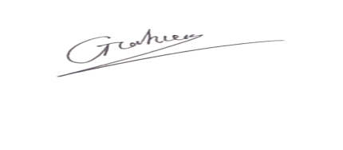
Hieu’s Signature:
Duc Anh’s Signature: 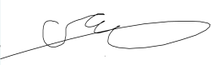
Dang’s Signature:: 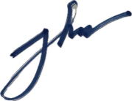
Pahan’s Signature:: 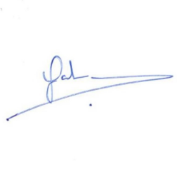
Date: 11th April, 2026

